**Name: Abdul Wahab Khan**

**SCD Lab 1.**  **Roll Number: 20K-1648**

**Task 1:**

Code:

import java.util.Scanner;

public class Student {

public String Name;

public String DepartmentName;

public int id;

public float marksobt;

public String [] subjects = new String [6];

public float tMarks;

//setter getter methods

public void setName(String Name){

this.Name = Name;

}

public String getName(){

return Name;

}

public void setid(int id){

this.id = id;

}

public void setDepartmentNameName(String DepartmentName){

this.DepartmentName = DepartmentName;

}

public String getDepartmentName(){

return DepartmentName;

}

public int getid(){

return id;

}

public void setmarksobt(float marksobt){

this.marksobt = marksobt;

}

public float getmarksobt(){

return marksobt;

}

public void settMarks(float tMarks){

this.tMarks = tMarks;

}

public float gettMarks(){

return tMarks;

}

public void setSubjects(String [] subjects){

this.subjects=subjects;

}

public String[] getSubjects(){

return subjects;

}

}

import java.util.Scanner;

public class Task1 {

public static void main(String[] args) {

Student s1 = new Student();

Scanner input = new Scanner(System.in);

System.out.println("Enter your name: ");

String Name = input.nextLine();

s1.setName(Name);

System.out.println("Enter your Department name: ");

String DepartmentName = input.nextLine();

s1.setDepartmentNameName(DepartmentName);

System.out.println("Enter your id: ");

int id = input.nextInt();

s1.setid(id);

System.out.println("Enter the name of all six subjects");

String [] subjects = new String [6];

for(int i=0;i<6;i++){

subjects[i]=input.nextLine();

}

s1.setSubjects(subjects);

System.out.println("Enter Total Marks of Six Subjects: ");

int tMarks= input.nextInt();

s1.settMarks(tMarks);

System.out.println("Enter marks obtained of Six Subjects: ");

int marksobt= input.nextInt();

s1.setmarksobt(marksobt);

float percentage = s1.getmarksobt()/s1.gettMarks()*100;

System.out.println("The name of the student is: " + s1.getName() + ", department name is: " + s1.getDepartmentName() + " and id is: " + s1.getid()+ ".");

System.out.println("His percentage is: " + percentage);

if(percentage>=90 && percentage<=100){

System.out.println("Grade is A*");

}

else if(percentage>=80 && percentage<=90){

System.out.println("Grade is A");

}

else if(percentage>=70 && percentage<=80){

System.out.println("Grade is B");

}

else{

System.out.println("Grade is C");

}

}

}

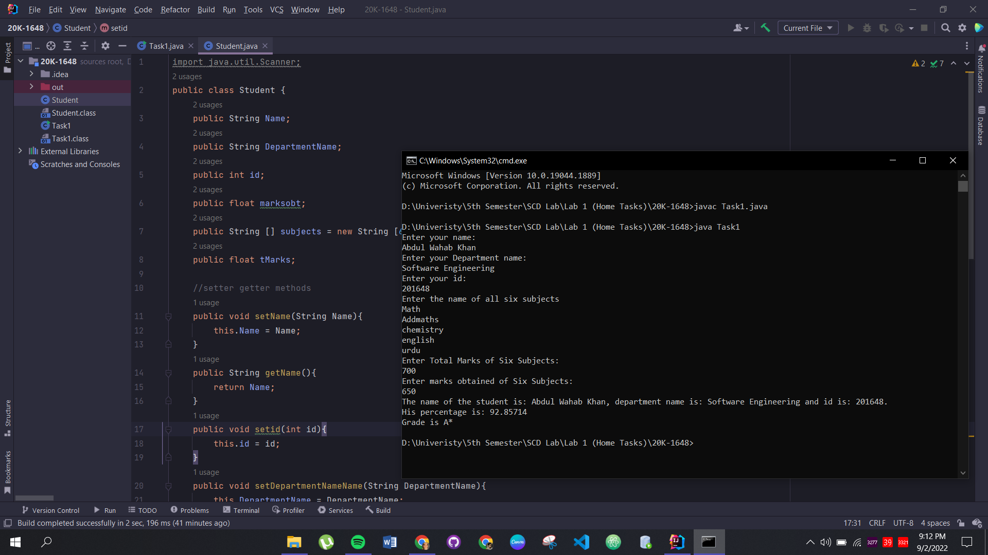

**Task 2:**

Code:

public class Teacher {

public String Name;

public String Institute;

public int age;

//mutators and accessors

public void setName(String Name){

this.Name = Name;

}

public String getName(){

return Name;

}

public void setage(int age){

this.age = age;

}

public void setInstitute(String Institute){this.Institute = Institute;}

public String getInstitute(){

return Institute;

}

public int getAge(){return age;}

}

public class HumanitiesTeacher extends Teacher{

public String Field;

public String CourseName;

public String Designation;

//mutators and accessors

public void setField(String Field){

this.Field = Field;

}

public String getField(){

return Field;

}

//mutators and accessors

public void setCourseName(String CourseName){

this.CourseName = CourseName;

}

public String getCourseName(){

return CourseName;

}

//mutators and accessors

public void setDesignation(String Designation){

this.Designation = Designation;

}

public String getDesignation(){

return Designation;

}

}

public class ScienceTeacher extends Teacher{

public String Field;

public String CourseName;

public String Designation;

public void setField(String Field){

this.Field = Field;

}

public String getField(){

return Field;

}

//mutators and accessors

public void setCourseName(String CourseName){

this.CourseName = CourseName;

}

public String getCourseName(){

return CourseName;

}

//mutators and accessors

public void setDesignation(String Designation){

this.Designation = Designation;

}

public String getDesignation(){

return Designation;

}

}

public class MathsTeacher extends Teacher{

public String Field;

public String CourseName;

public String Designation;

public void setField(String Field){

this.Field = Field;

}

public String getField(){

return Field;

}

//mutators and accessors

public void setCourseName(String CourseName){

this.CourseName = CourseName;

}

public String getCourseName(){

return CourseName;

}

//mutators and accessors

public void setDesignation(String Designation){

this.Designation = Designation;

}

public String getDesignation(){

return Designation;

}

}

import java.util.Scanner;

public class Task2 {

public static void main(String[] args) {

Scanner input = new Scanner(System.in);

HumanitiesTeacher HT = new HumanitiesTeacher();

System.out.println("Enter the name of the Teacher: ");

String Name = input.nextLine();

HT.setName(Name);

System.out.println("Enter the age of the Teacher: ");

int age = input.nextInt();

HT.setage(age);

input.nextLine();

System.out.println("Enter the Institute of the Teacher: ");

String Institute = input.nextLine();

HT.setInstitute(Institute);

System.out.println("Enter the Field of the Teacher: ");

String Field = input.nextLine();

HT.setField(Field);

System.out.println("Enter the Course Name of the Teacher: ");

String CourseName = input.nextLine();

HT.setCourseName(CourseName);

System.out.println("Enter the Designation of the Teacher: ");

String Designation = input.nextLine();

HT.setDesignation(Designation);

System.out.println("Name of the teacher is: " + HT.getName() + ", age is: " + HT.getAge() + ", Institute is: " + HT.getInstitute() + ", Field is: "+ HT.getField() + ", Course Name is " + HT.getCourseName() + ", designation is: " + HT.getDesignation());

}

}

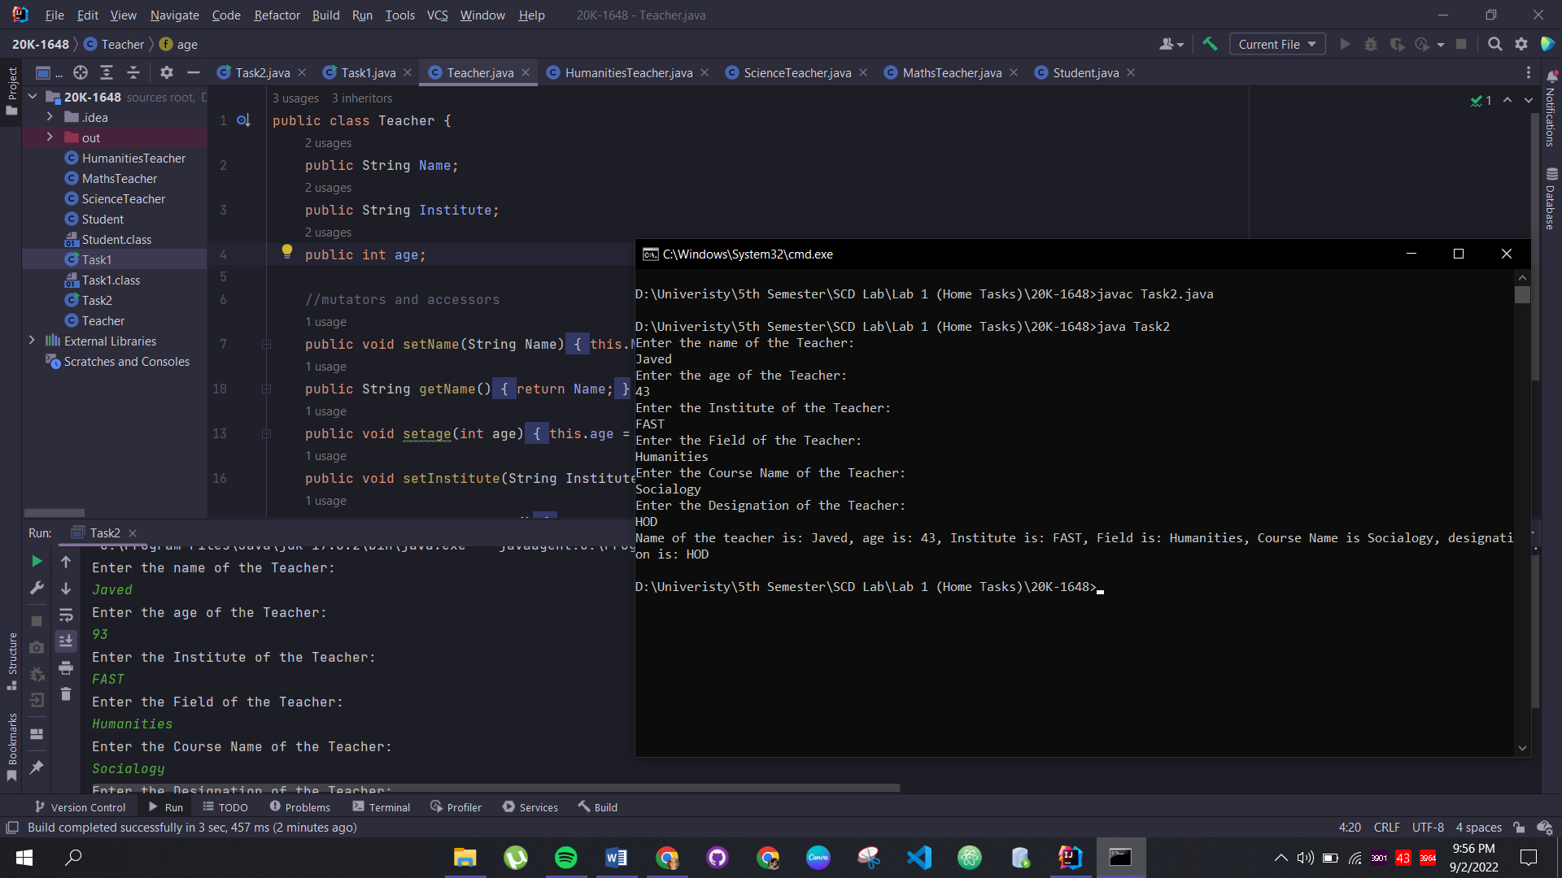

**Task 3:**

Code:

public class Weapons {

}

public class HotWeapons extends Weapons{

public void HotWeaponsDescription(){

System.out.println("Hot weapons uses gunpowder, or explode.");

}

}

public class Bombs extends HotWeapons{

public void BombsDescription(){

System.out.println("Bombs blow up.");

}

}

public class NuclearBombs extends Bombs{

public void NueclearBombsDescription(){

System.out.println("Nuclear bombs blow up, and use nuclear fission and fusion.");

}

}

public class Task3 {

public static void main(String[] args) {

NuclearBombs NB = new NuclearBombs();

NB.NueclearBombsDescription();

Bombs B = new Bombs();

B.BombsDescription();

HotWeapons HW = new HotWeapons();

HW.HotWeaponsDescription();

}

}

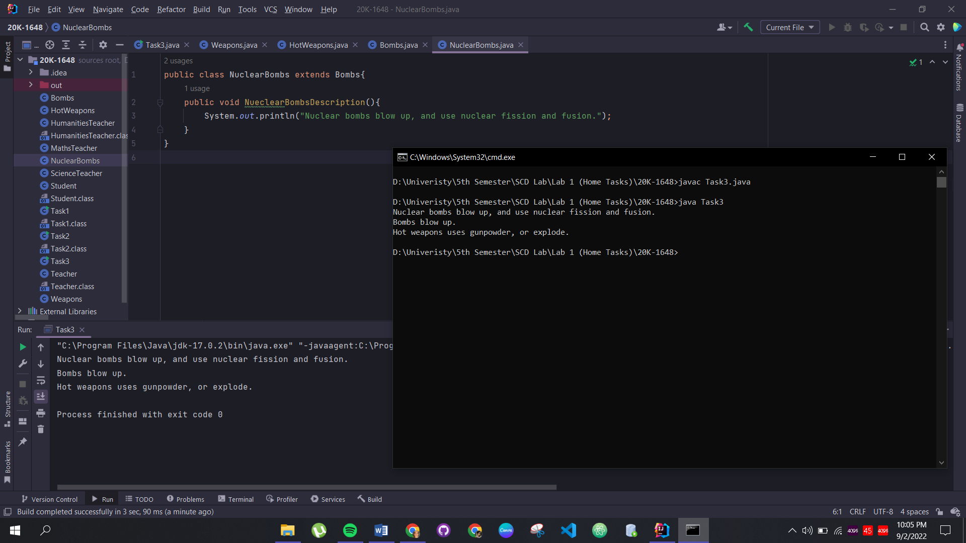

**Task 4:**

Code:

class person{

private String name;

private String occupation;

person(String occupation){

this.occupation=occupation;

}

public String getName() {

return name;

}

public void setName(String name) {

this.name = name;

}

public String getOccupation() {

return occupation;

}

//method

void draw(){

System.out.println("A person can draw in many ways");

}

}

class artist extends person{

artist(String occupation) {

super(occupation);

}

void draw(){

System.out.println("An artist can draw with a paint brush");

}

}

class gunman extends person{

gunman(String occupation) {

super(occupation);

}

void draw(){

System.out.println("A gunman draws a gun to shoot");

}

}

public class Task4 {

public static void main(String[] args) {

artist a = new artist("artish");

gunman g = new gunman("gunman");

a.draw();

g.draw();

}

}

